Plotting an acid/base reaction
Science Understanding Visual/Spatial Logical/Mathematical
A solution of sodium hydroxide was slowly added to a solution of hydrochloric acid. As the sodium hydroxide was added, the pH of the solution was continually measured using a pH meter. The results are shown in the table below:
Volume of NaOH added (mL) | pH | Volume of NaOH added (mL) | pH
0 | 2.5 | 12.5 | 8.5
2 | 3.2 | 13 | 11.6
4 | 3.6 | 14 | 12.2
6 | 4.0 | 15 | 12.4
8 | 4.2 | 17 | 12.8
10 | 4.6 | 19 | 13.0
12 | 5.4 | 20 | 13.1
1 Use this data to construct a line graph that shows what happened to the pH as sodium hydroxide was added. Connect up the points with a smooth curve.
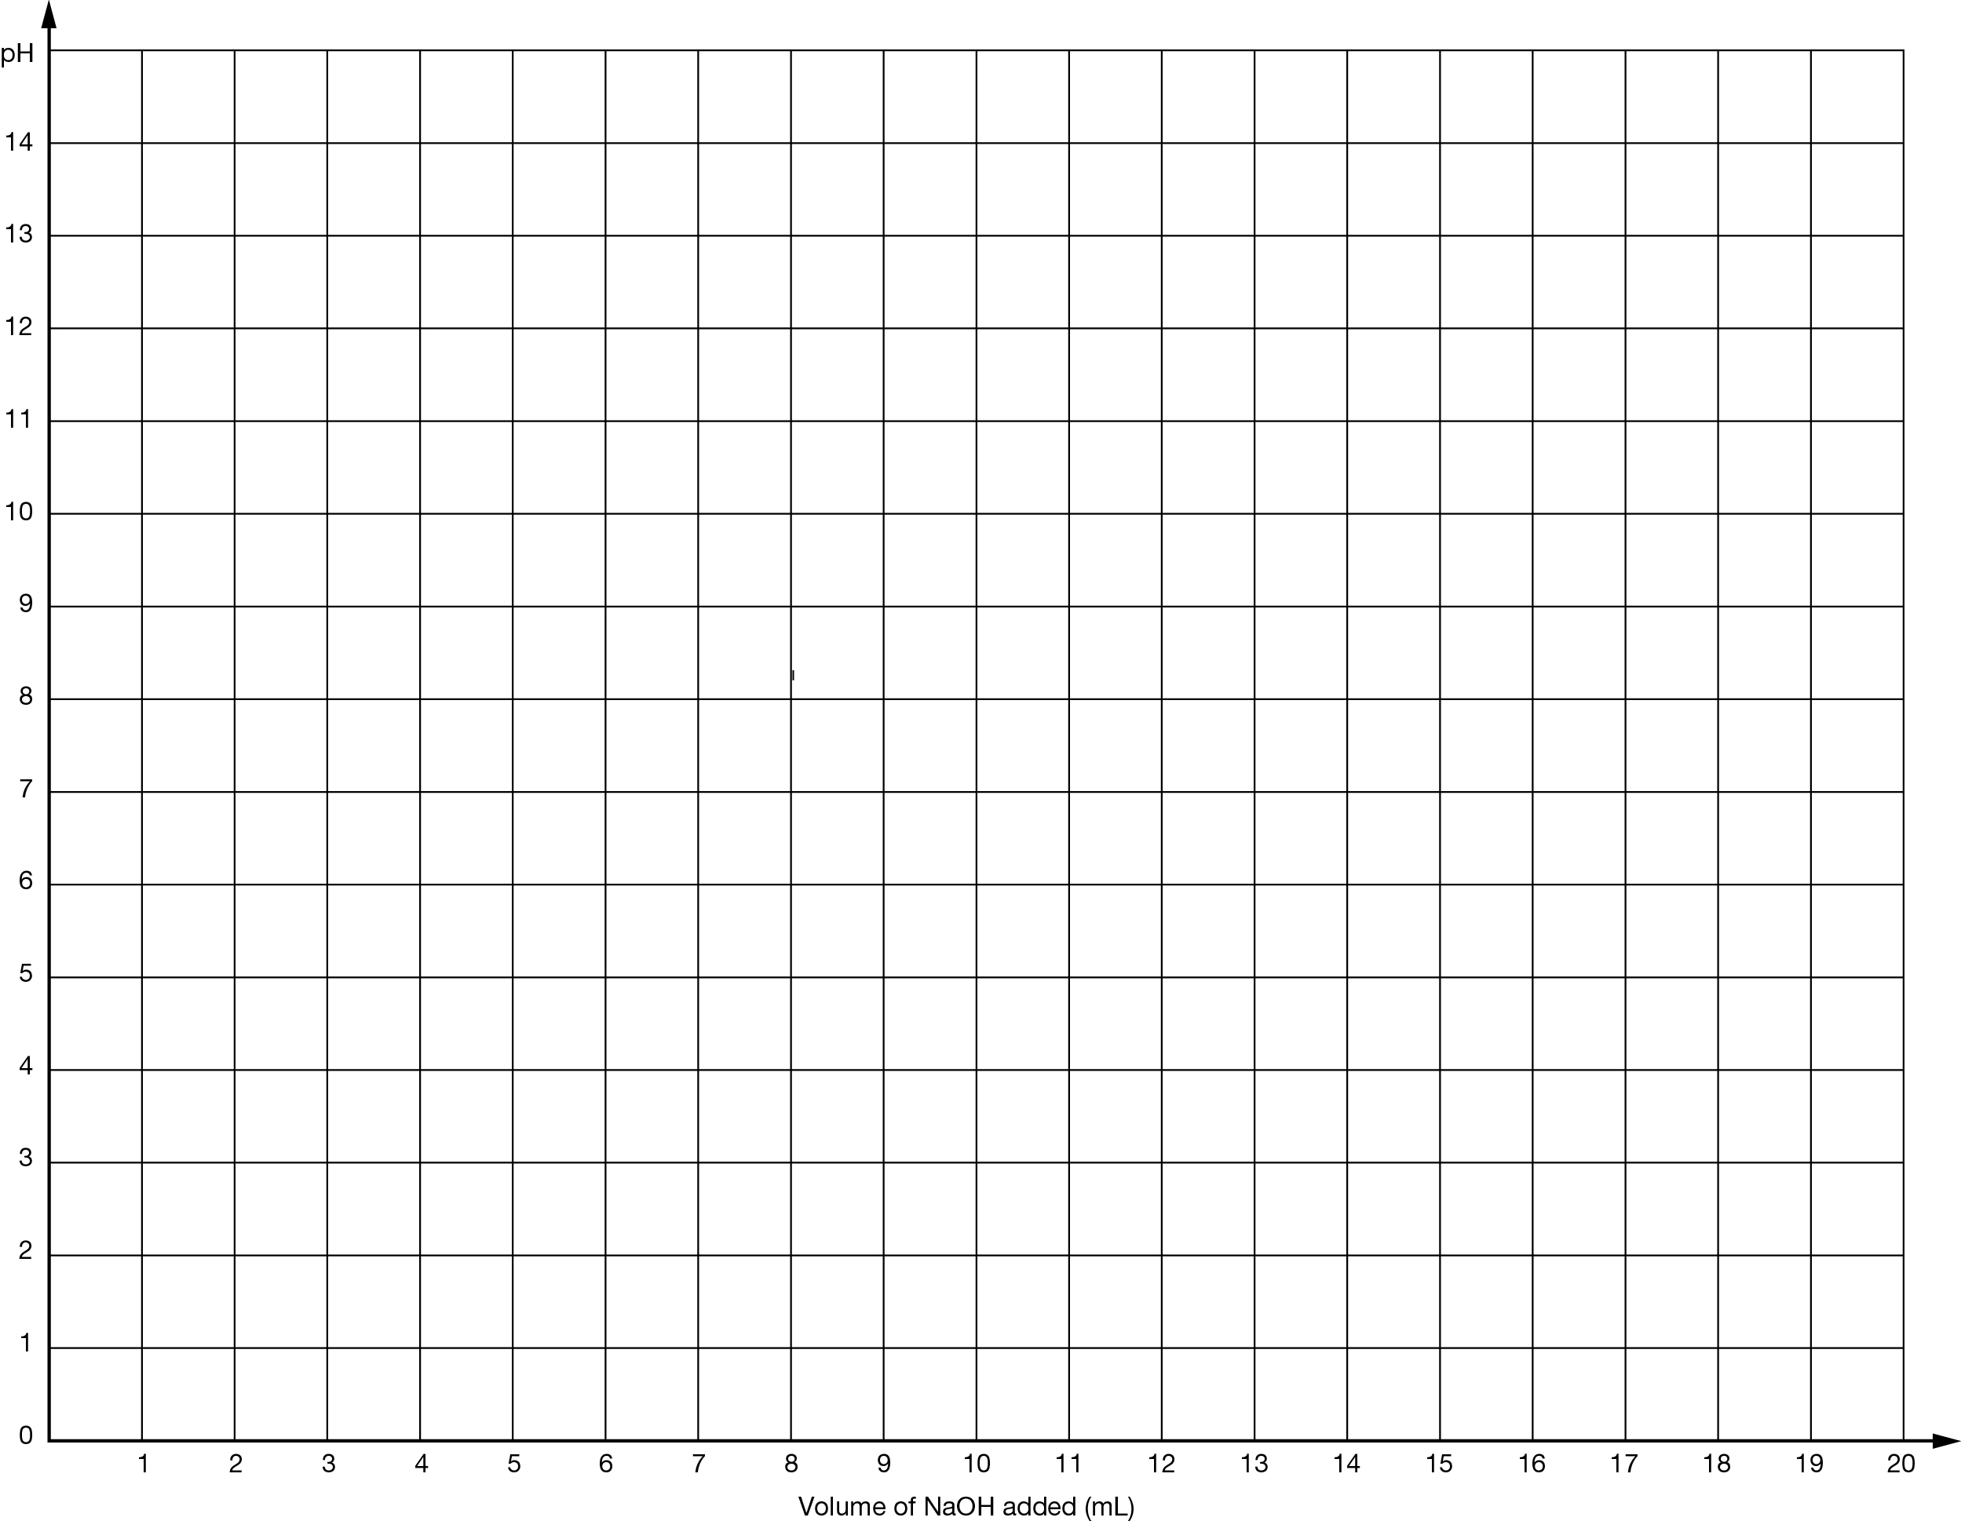

2 Classify the type of reaction happening here. Was it an acid/metal, neutralisation or acid/carbonate reaction?

3 State what the pH of the hydrochloric acid solution was before any reaction had taken place.

4 State the pH of the solution at the end of the reaction.

5 State whether the solution was acidic, basic or neutral when the following volumes of sodium hydroxide had been added:
a 5 mL
b 16 mL
c 19 mL
d 10 mL
6 State the approximate volume of sodium hydroxide that needed to be added to exactly neutralise the acid (when the pH is approximately 7).

7 Write a word equation to describe the reaction between sodium hydroxide and hydrochloric acid.

8 Write a word equation to describe each of the following acid/hydroxide base reactions:
a sulfuric acid and calcium hydroxide

b acetic acid and calcium hydroxide

c sodium hydroxide and nitric acid

